**Guidance Bulletin** 

**No. 2021-01**

**FOOTWAY OR NO WAY!**

**Working on the Footway and Managing Pedestrians**

There is an implicit hierarchy for footway work within the Safety at Street Works and Road Works Code of Practice (Red Book) giving the order in which you should consider the options. The safety code says that you **should always** try to enable pedestrians to remain on the footway and that the remaining width available to them should ideally be a minimum of 1.5m, so that is the preferred option and it is therefore the first in the hierarchy. If there is not enough room for 1.5m, you should then consider the next option, and so on. The basic rule is that you should **not** choose an option **without good reason** if the one above it would work. The hierarchy is as follows: 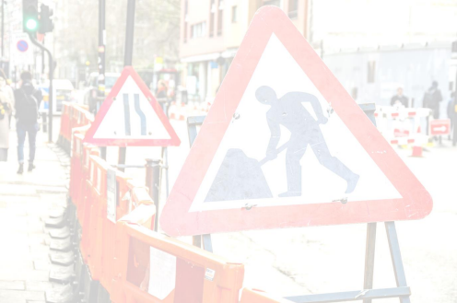

1 **Works partially obstruct footway**, 1.5 m minimum width remaining for pedestrians.*

2 **Works partially obstruct footway**, 1.0 m minimum width remaining for pedestrians.*

3 **Footway closed, 1.2 m minimum** width walkway provided in the carriageway.

4 **Footway closed, 1.0 m minimum** width walkway provided in the carriageway.

5 **Footway closed, no walkway in the carriageway**, pedestrians expected to use footway on opposite side. *\* This could be done with the authorised use of footway boards*

Whichever option is chosen; it should be accompanied by an appropriate site risk assessment. Note that the above are minimum widths, **not widths to aim for**. For example, if you have to resort to option 3 because options 1 and 2 won't work, don't go straight to 1.2m if there is room for a wider walkway.

**DO’s & DON’Ts**

• **DO** Consider **ALL ALTERNATIVES** before you close a footway

• **DO** Complete a street works site specific risk assessment

• **DO** Make sure you walk any alternative routes to ensure they are safe and compliant.

• **DO** Consider the safety of adults, children, wheelchair users and the partially sighted when selecting method. • **DO** Consider

• Rush Hour Traffic

• School run parking

• Pub/Club Licensing hours

• One off events such as match days etc.

• Access to shops and premises

• **DON’T** Close a footway unless you have to. Use your site specific **RISK ASSESMENT**

• **DON’T** Leave a site without checking it is still safe for pedestrians.

• **DON’T** Commence works on the opposite side of the road to a footway closure

• **DON’T** Start work until you are sure how you are going to manage pedestrians safely past/ though your works. • **DON’T** Use footway boards without following the correct process and fixing them in position.

**\*HAUC(UK) thanks Morrison Water Services in their help in the creation of this guidance. **

**This information is general guidance only and is not intended to replace specific legal advice. None of HAUC(UK) or its members, accept any liability for any action or omission taken based on this guidance.**